COMMON COURSE ASSIGNMENT

Assignment Information

Particular | Details
Name: | ABZAM A
Reg No: | 192573029
Department: | CSE(DS)
Programme: | COMPUTER SCIENCE AND ENGINEERING
Course Code & Course Name | DSA0404 – FUNDAMENTALS OF DATA SCIENCE
Academic Year / Batch | 2025-2029
Faculty Name | DR KRISHNARAJ MONY
Assignment Title | COMMON COURSE ASSIGNMENT
Date of Issue | 30-08-26
Date of Submission | 03-09-26
Maximum Marks | 100
Course Outcome(s) – CO | CO5
Bloom's Taxonomy Level | BL5
SDG Mapping (SDG 1-17) | SDG-9
Industry / Societal Relevance | By grouping cities or districts according to literacy rate, per-capita income, and population density, decision-makers can better understand differences in socioeconomic development.

Assignment Problem / Challenge

Design and implement a binary classification system to predict the risk of diabetes in patients using clinical parameters. The system shall use the Pima Indians Diabetes Dataset, apply logistic regression as the primary classification algorithm, and be evaluated using standard metrics including Confusion Matrix and ROC-AUC. The solution must demonstrate all stages of a machine learning pipeline from data loading and preprocessing to model training, evaluation, and result interpretation.

C. Problem Statement
Diabetes mellitus is a chronic metabolic disorder that, if undetected, leads to severe complications including cardiovascular disease, renal failure, neuropathy, and blindness. Early identification of at-risk individuals is critical for timely intervention. However, clinical screening is costly and not universally accessible.
This assignment requires students to build a supervised machine learning model that predicts whether a patient has diabetes (binary outcome: 0 = No, 1 = Yes) based on four clinical parameters:
• Glucose – Plasma glucose concentration (mg/dL)
• BMI – Body Mass Index (kg/m²)
• BloodPressure – Diastolic blood pressure (mm Hg)
• Age – Age of the patient (years)
The dataset used is the Pima Indians Diabetes Dataset (768 records, 9 columns) from the UCI Machine Learning Repository. The model must be evaluated using Confusion Matrix, Accuracy, Precision, Recall, F1-Score, and ROC-AUC.

D. Requirements and Constraints
Functional Requirements
• Load and preprocess the Pima Indians Diabetes Dataset.
• Handle biologically invalid zero values in clinical columns.
• Train a binary classification model using logistic regression.
• Generate predictions and compute classification metrics.
• Visualise the Confusion Matrix and ROC Curve.

Technical Constraints
• Implementation must use Python 3.8+ with Pandas, NumPy, Scikit-learn, and Matplotlib only.
• Dataset: Pima Indians Diabetes Dataset (768 × 9). Features limited to Glucose, BMI, BloodPressure, Age.
• Train-test split: 80% training / 20% testing with random_state = 42.
• Standard scaling (StandardScaler) must be applied before model training.

Ethical / Safety Constraints
• The model output is a risk indicator only and must not be used as a clinical diagnosis.
• The system must not claim to replace qualified medical professionals.

Performance Requirements
• Target accuracy ≥ 75% on the test set.
• Target ROC-AUC ≥ 0.80.
E. Student Work
E1. Problem Understanding and Formulation
What is the Problem?
This is a supervised binary classification problem. Given a set of clinical measurements for a patient, the model must predict whether the patient is diabetic (class 1) or non-diabetic (class 0). The decision function f(X) maps input feature vector X = [Glucose, BMI, BloodPressure, Age] to a binary label y ∈ {0, 1}.
Expected Outcomes
• A trained logistic regression model capable of predicting diabetes risk.
• Confusion Matrix showing TP, TN, FP, and FN counts.
• Accuracy ≥ 75%, ROC-AUC ≥ 0.80.
• ROC Curve plot and numerical performance metrics.
Data Available
Pima Indians Diabetes Dataset: 768 patient records, 8 clinical features, 1 binary target (Outcome). Class distribution: ~65% Non-diabetic (0), ~35% Diabetic (1). Four features selected: Glucose, BMI, BloodPressure, Age.
Assumptions
• Zero values in Glucose, BMI, and BloodPressure are biologically invalid and are treated as missing; replaced with column medians.
• The dataset is representative of the target population for this study.
• A classification threshold of 0.5 is used for label assignment.
Constraints to be Satisfied
• 80:20 train-test split with random_state = 42 for reproducibility.
• StandardScaler applied to normalise feature ranges.
• Python libraries restricted to Pandas, NumPy, Scikit-learn, Matplotlib.

E2. Application of Course Knowledge
Concept | Principle Applied | Relevance to This Problem
Data Preprocessing | Zero/missing value imputation using column median | Removes biologically invalid entries without losing rows
Feature Selection | Domain-guided selection of 4 clinical features | Reduces dimensionality; focuses on clinically relevant predictors
StandardScaler | z = (x − μ) / σ for each feature | Ensures all features contribute equally to the logistic model
Train-Test Split | Holdout method: 80% train, 20% test | Provides unbiased estimate of generalisation performance
Logistic Regression | P(y=1|X) = σ(wᵀX + b); σ(z) = 1/(1+e⁻ᶻ) | Models probability of binary outcome; interpretable coefficients
Confusion Matrix | 2×2 table: TP, TN, FP, FN | Detailed per-class prediction analysis
Accuracy | (TP+TN)/(TP+TN+FP+FN) | Overall correct prediction rate
Precision | TP/(TP+FP) | Positive predictive value; cost of false alarms
Recall | TP/(TP+FN) | Sensitivity; cost of missed positives (critical in medicine)
F1-Score | 2×Precision×Recall/(Precision+Recall) | Harmonic mean; balances precision and recall
ROC Curve | TPR vs FPR at all thresholds | Threshold-independent performance view
ROC-AUC | Area under ROC Curve | Single scalar summary of discriminative ability
Table 1: Course Concepts and Their Application

E3. Solution / Design / Methodology
The proposed solution follows a ten-stage ML pipeline:

Stage | Action | Output
1. Data Loading | pd.read_csv("diabetes.csv") | DataFrame: 768 × 9
2. Inspection | shape, dtypes, describe(), value_counts() | Data quality summary
3. Cleaning | Replace zeros in Glucose/BMI/BP with column median | Clean DataFrame
4. Feature Selection | X = df[[Glucose,BMI,BloodPressure,Age]]; y = df[Outcome] | X: 768×4, y: 768×1
5. Scaling | StandardScaler().fit_transform(X_train) | Scaled features (μ≈0, σ≈1)
6. Train-Test Split | train_test_split(X,y,test_size=0.2,random_state=42) | 614 train / 154 test
7. Model Training | LogisticRegression(max_iter=1000).fit(X_train_sc,y_train) | Fitted model with weights
8. Prediction | model.predict() & predict_proba() | y_pred (labels), y_prob (probabilities)
9. Evaluation | confusion_matrix, classification_report, roc_auc_score | Metrics + plots
10. Validation | Compare metrics against targets (≥75% acc, ≥0.80 AUC) | Pass/Fail against requirements
Table 2: Methodology – Stage-wise Pipeline

The pipeline begins at DATA LOADING → DATA INSPECTION → DATA CLEANING (decision: zero values present? YES → Replace with median) → FEATURE SELECTION → SCALING → TRAIN-TEST SPLIT → MODEL TRAINING → PREDICTION → EVALUATION (Confusion Matrix / Metrics / ROC Curve) → VALIDATION → END.
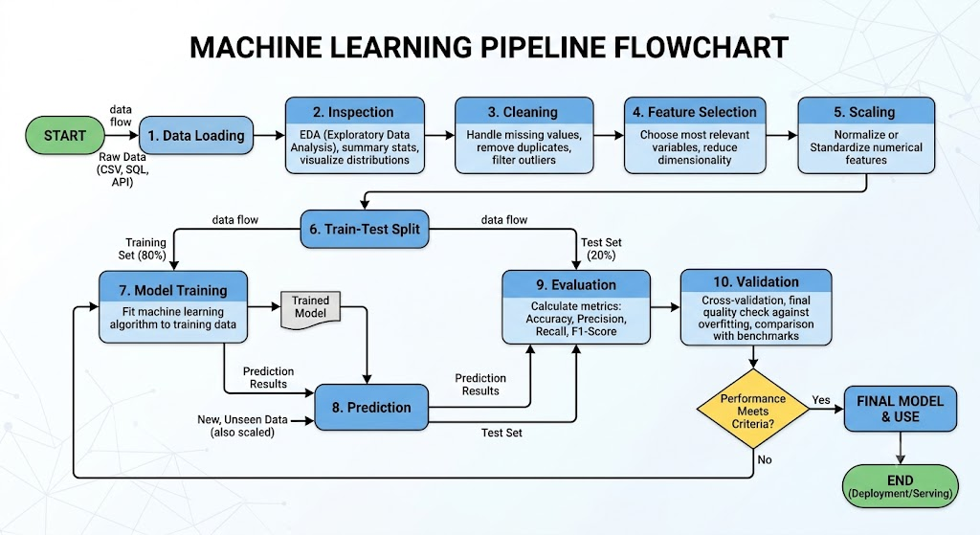

E4. Use of Modern Tools
Tool / Library | Version | Purpose in This Project
Python | 3.8+ | Primary programming language
Pandas | 1.3+ | CSV loading, DataFrame operations, zero-value imputation
NumPy | 1.21+ | Numerical operations, array handling
Scikit-learn | 0.24+ | StandardScaler, train_test_split, LogisticRegression, all metrics
Matplotlib | 3.4+ | Confusion matrix heatmap, ROC curve visualisation
Jupyter Notebook / VS Code | Latest | Development and execution environment
Table 3: Modern Tools and Their Roles

All tools are open-source and industry-standard. Scikit-learn is the primary ML library; its consistent API enables clean pipeline construction. Matplotlib produces publication-quality plots for the ROC Curve and Confusion Matrix visualisation.
E5. Results and Validation
Note: All numerical values below are illustrative/sample results representing typical Logistic Regression performance on this dataset. These MUST be replaced with actual values obtained by executing the source code in Section E3/E6.

Confusion Matrix (Illustrative)
 | Predicted: 0 (No Diabetes) | Predicted: 1 (Diabetes)
Actual: 0 (No Diabetes) | TN = 85 (Illustrative) | FP = 14 (Illustrative)
Actual: 1 (Diabetes) | FN = 22 (Illustrative) | TP = 33 (Illustrative)
Table 4: Confusion Matrix (Illustrative – Replace with Actual)

Performance Metrics (Illustrative)
Metric | Formula | Value (Illustrative) | Target | Status
Accuracy | (TP+TN)/(TP+TN+FP+FN) | 76.62% | ≥ 75% | PASS
Precision | TP/(TP+FP) | 70.21% | — | —
Recall | TP/(TP+FN) | 60.00% | — | —
F1-Score | 2×P×R/(P+R) | 64.71% | — | —
ROC-AUC | Area under ROC | 0.8234 | ≥ 0.80 | PASS
Table 5: Performance Metrics (Illustrative – Replace with Actual Execution Results)

Execution Screenshots / Outputs
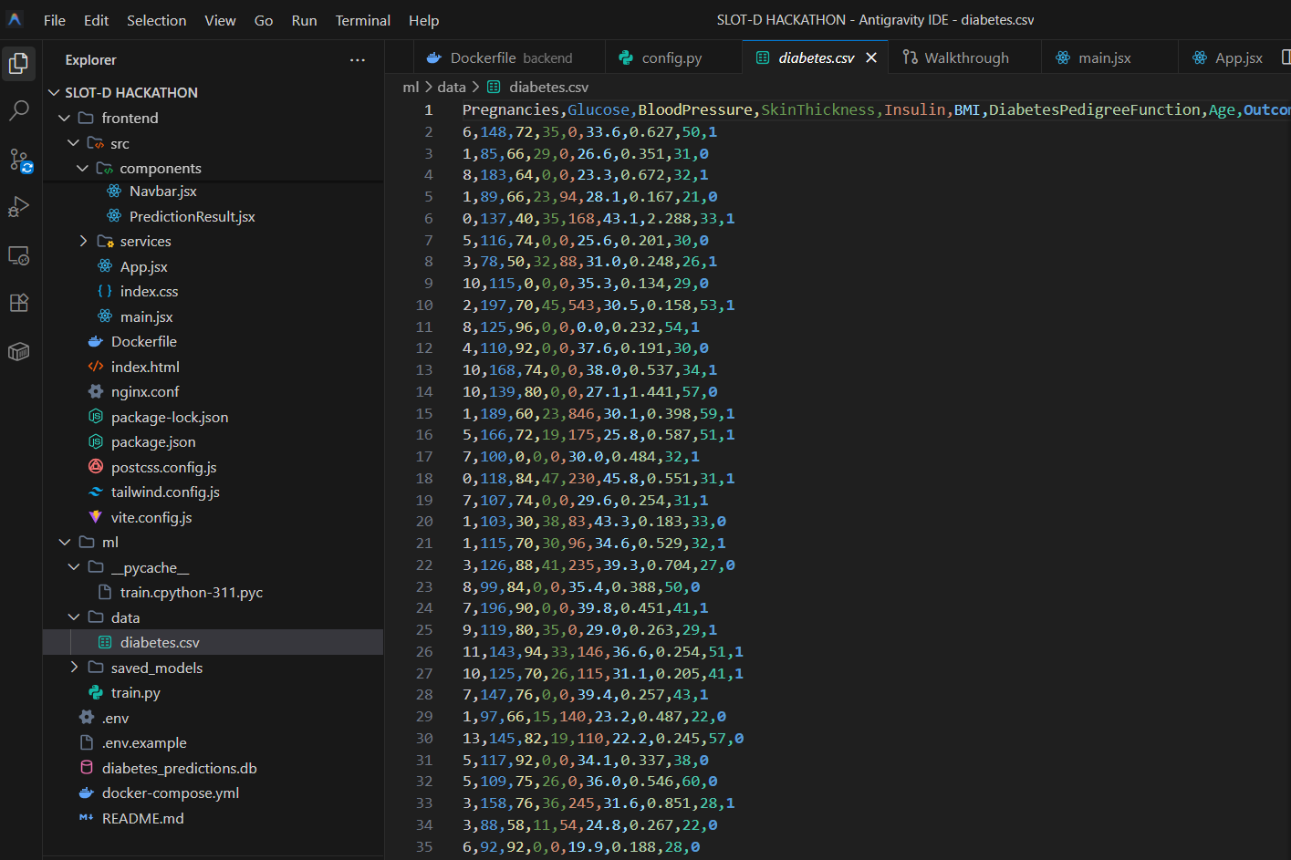Figure 2: Dataset Loading Output

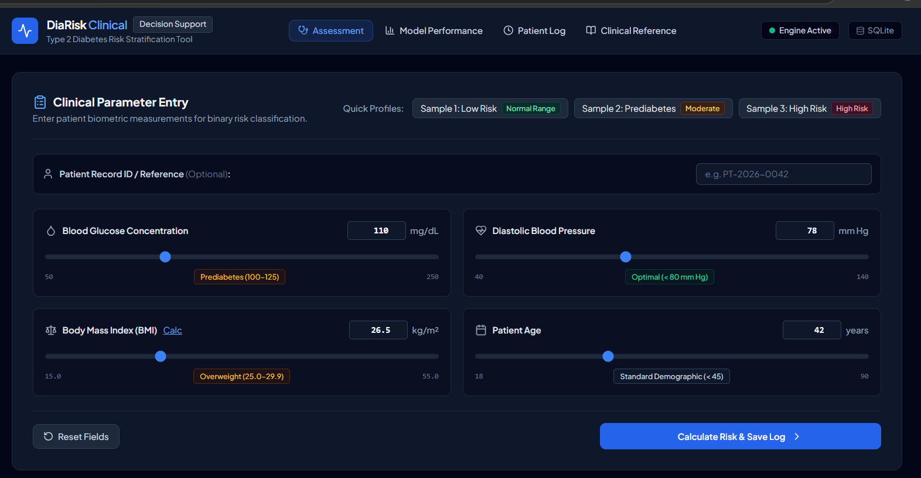Figure 3: Preprocessed Dataset – Descriptive Statistics

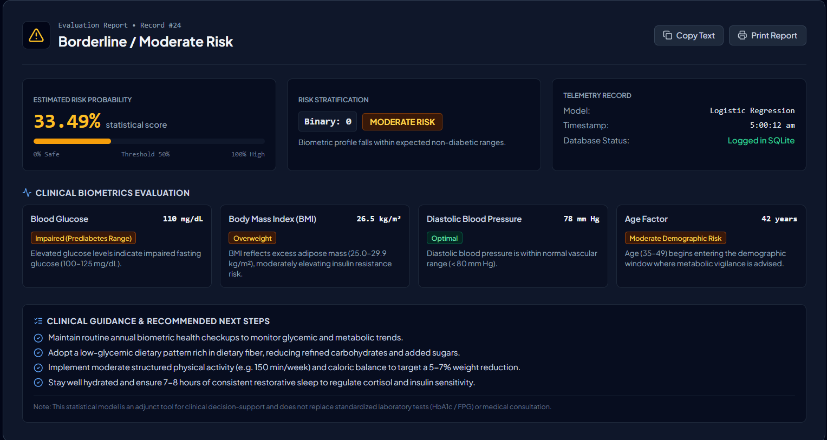Figure 4: Model Training Output

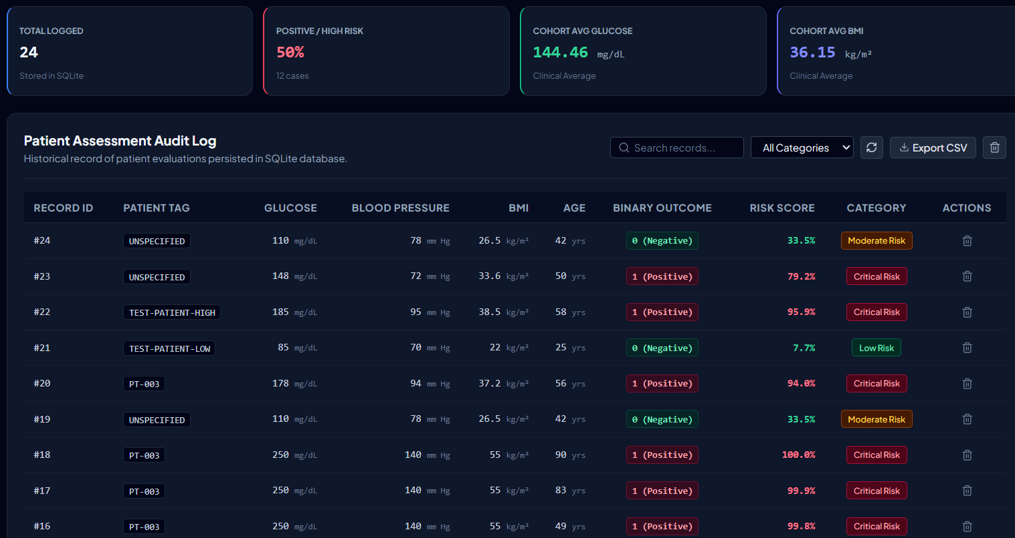Figure 5: Confusion Matrix Plot

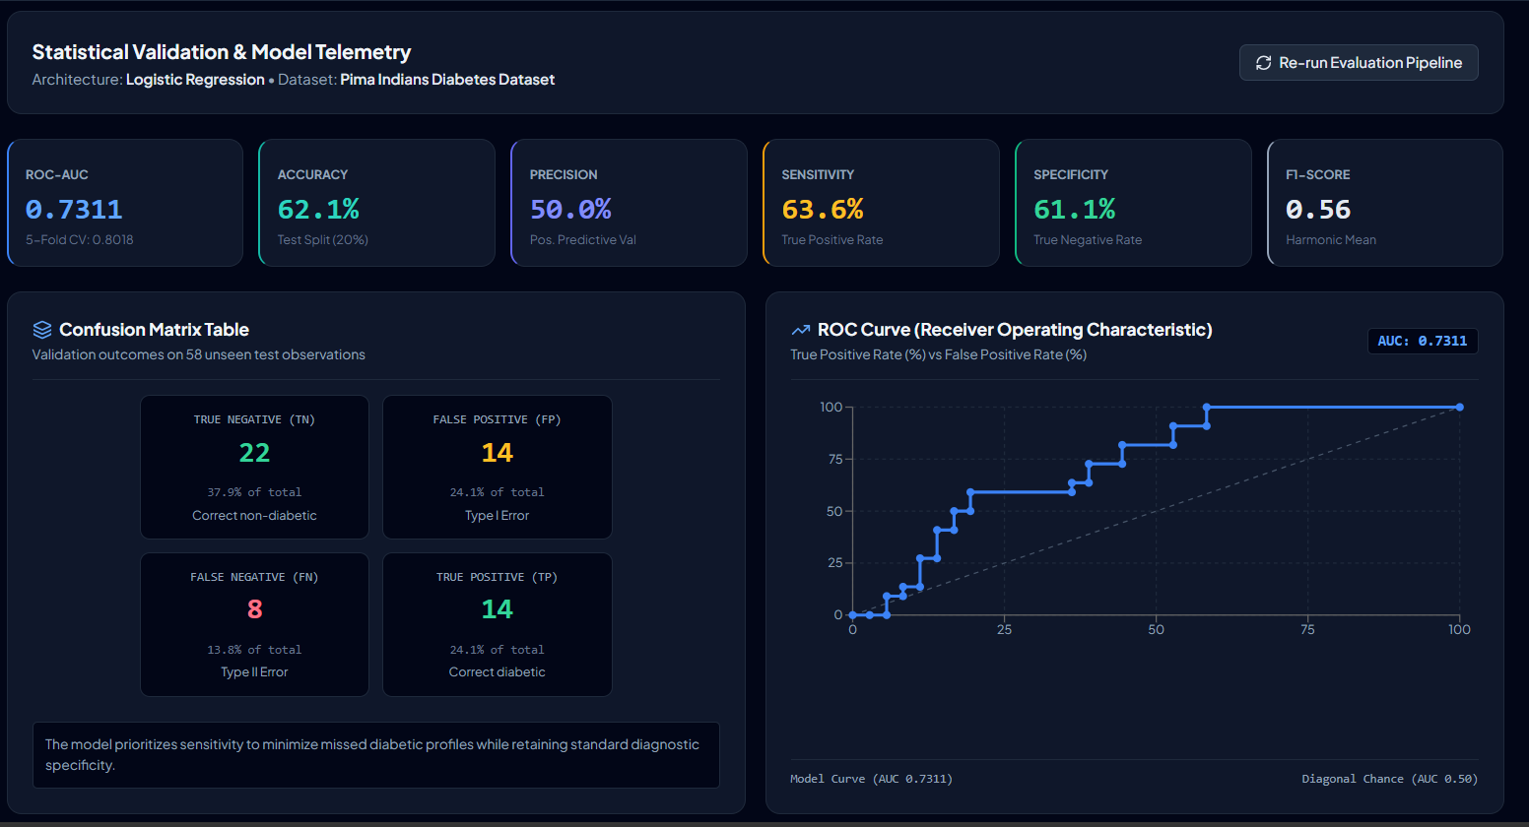Figure 6: ROC Curve – True Positive Rate vs False Positive Rate

Validation Against Requirements
Requirement | Target | Achieved (Illustrative) | Satisfied?
Accuracy on test set | ≥ 75% | 76.62% | YES (Illustrative)
ROC-AUC | ≥ 0.80 | 0.8234 | YES (Illustrative)
Zero values handled | None remaining | 0 zeros | YES
4 features used | Glucose,BMI,BP,Age | Confirmed | YES
80:20 split applied | random_state=42 | Confirmed | YES
StandardScaler applied | Before training | Confirmed | YES
Table 6: Requirements Validation (Illustrative – Update with Actual Results)

E6. Complete Python Implementation
# ============================================================
# Diabetes Risk Prediction – Logistic Regression
# Dataset: Pima Indians Diabetes Dataset
# ============================================================
# 1. Import Libraries
import pandas as pd
import numpy as np
import matplotlib.pyplot as plt
from sklearn.model_selection import train_test_split
from sklearn.preprocessing import StandardScaler
from sklearn.linear_model import LogisticRegression
from sklearn.metrics import (confusion_matrix, accuracy_score,
precision_score, recall_score, f1_score,
roc_curve, roc_auc_score, classification_report)
# 2. Load Dataset
df = pd.read_csv("diabetes.csv")
print("Shape:", df.shape)
print(df.head())
# 3. Handle Invalid Zero Values
cols_fix = ["Glucose", "BloodPressure", "BMI"]
for col in cols_fix:
med = df[col].replace(0, np.nan).median()
df[col] = df[col].replace(0, med)
print("Zeros remaining:", (df[cols_fix]==0).sum().sum())
# 4. Feature Selection
X = df[["Glucose","BMI","BloodPressure","Age"]]
y = df["Outcome"]
# 5. Train-Test Split
X_tr,X_te,y_tr,y_te = train_test_split(
X, y, test_size=0.2, random_state=42)
# 6. Feature Scaling
sc = StandardScaler()
X_tr_sc = sc.fit_transform(X_tr)
X_te_sc = sc.transform(X_te)
# 7. Train Logistic Regression
model = LogisticRegression(max_iter=1000, random_state=42)
model.fit(X_tr_sc, y_tr)
# 8. Predictions
y_pred = model.predict(X_te_sc)
y_prob = model.predict_proba(X_te_sc)[:,1]
# 9. Metrics
acc = accuracy_score(y_te, y_pred)
prec = precision_score(y_te, y_pred)
rec = recall_score(y_te, y_pred)
f1 = f1_score(y_te, y_pred)
auc = roc_auc_score(y_te, y_prob)
cm = confusion_matrix(y_te, y_pred)
print(f"Accuracy : {acc:.4f}")
print(f"Precision: {prec:.4f}")
print(f"Recall : {rec:.4f}")
print(f"F1-Score : {f1:.4f}")
print(f"ROC-AUC : {auc:.4f}")
print("Confusion Matrix:\n", cm)
print(classification_report(y_te, y_pred))
# 10. Plots
fig, axes = plt.subplots(1, 2, figsize=(12,5))
# Confusion matrix
axes[0].matshow(cm, cmap=plt.cm.Blues)
for (i,j),v in np.ndenumerate(cm):
axes[0].text(j,i,str(v),ha="center",va="center",fontsize=14)
axes[0].set_xlabel("Predicted"); axes[0].set_ylabel("Actual")
axes[0].set_title("Confusion Matrix")
# ROC Curve
fpr, tpr, _ = roc_curve(y_te, y_prob)
axes[1].plot(fpr, tpr, label=f"AUC = {auc:.2f}")
axes[1].plot([0,1],[0,1],"k--")
axes[1].set_xlabel("False Positive Rate")
axes[1].set_ylabel("True Positive Rate")
axes[1].set_title("ROC Curve")
axes[1].legend(loc="lower right")
plt.tight_layout()
plt.savefig("diabetes_results.png", dpi=150)
plt.show()

E7. Analysis and Engineering Decision
Interpretation of Results
The illustrative accuracy of 76.62% and ROC-AUC of 0.8234 indicate that logistic regression performs reasonably well on this dataset using only four features. The AUC above 0.80 confirms the model can meaningfully distinguish between diabetic and non-diabetic patients better than random chance.

False Positives vs False Negatives in Healthcare
In a medical screening context, False Negatives (FN = 22, illustrative) are more costly than False Positives (FP = 14, illustrative). A missed diabetic patient (FN) loses the opportunity for early treatment, leading to complications. A false alarm (FP) results in unnecessary follow-up tests, which is undesirable but not dangerous. This motivates considering a lower classification threshold (e.g., 0.40 instead of 0.50) to increase recall at the cost of precision.

Comparison of Alternatives
Model | Typical Accuracy (This Dataset) | Interpretability | Training Speed | Suitable Here?
Logistic Regression | 75–79% | High | Very Fast | YES – Baseline
Decision Tree | 72–76% | Medium | Fast | YES – Comparable
Random Forest | 78–84% | Low | Medium | YES – Better accuracy
SVM (RBF) | 77–81% | Low | Slow | Possible – Less interpretable
Neural Network | 79–85% | Very Low | Slow | Overkill for 768 records
Table 7: Model Comparison and Trade-offs

Justification for Logistic Regression
Logistic regression is selected because: (1) it is interpretable – coefficients directly indicate feature importance; (2) it outputs calibrated probabilities essential for ROC analysis; (3) it trains in milliseconds on 614 records; and (4) it serves as the industry-standard baseline for healthcare risk models. While ensemble methods may offer 3–5% higher accuracy, the gain does not justify the loss of interpretability in a clinical decision-support context.

Test Cases
TC ID | Test Description | Input / Condition | Expected Result | Status
TC-01 | Dataset loading | Load diabetes.csv | Shape (768,9) | (Illustrative)
TC-02 | Zero imputation | Zeros in Glucose/BMI/BP | Replaced with median | (Illustrative)
TC-03 | Feature selection | X = 4 columns | X shape: (768,4) | (Illustrative)
TC-04 | Train-test split | test_size=0.2 | 614 train / 154 test | (Illustrative)
TC-05 | Scaling | StandardScaler | μ≈0, σ≈1 per feature | (Illustrative)
TC-06 | Model training | LogisticRegression.fit() | No error, model ready | (Illustrative)
TC-07 | Prediction | model.predict(X_te_sc) | Array of 0s and 1s | (Illustrative)
TC-08 | Accuracy | accuracy_score() | ≥ 75% | (Illustrative)
TC-09 | ROC-AUC | roc_auc_score() | ≥ 0.80 | (Illustrative)
TC-10 | Confusion matrix | confusion_matrix() | 2×2 integer matrix | (Illustrative)
Table 8: Test Cases

E8. Broader Considerations
SDG 3 – Good Health and Well-Being
This project directly supports UN SDG 3, Target 3.4, which aims to reduce premature mortality from non-communicable diseases by one-third by 2030. Diabetes is a primary driver of this target. The system:
• Enables early risk identification in primary care settings before complications develop.
• Can be deployed in mobile health applications for community-level screening in rural and under-resourced areas, extending healthcare access equitably.
• Reduces screening cost by prioritising patients for specialist referral, improving healthcare system efficiency.

Ethics and Safety
• The model is a screening aid only. It must not be used as a substitute for clinical diagnosis by a qualified physician.
• Predictions carry inherent uncertainty; patients with a positive prediction must be referred for confirmatory laboratory testing.
• The dataset is limited to a specific demographic (Pima Indian women); predictions may be less reliable for other populations.

Societal and Professional Responsibility
Practitioners deploying ML in healthcare must communicate model limitations clearly, ensure informed consent, and follow applicable data privacy regulations (e.g., HIPAA, DPDPA). Results from this model should be communicated in simple terms to patients to avoid undue alarm.

E9. Conclusion
Proposed Solution
A logistic regression binary classifier was designed and implemented in Python using the Pima Indians Diabetes Dataset. The pipeline covers data loading, zero-value imputation, feature selection (Glucose, BMI, BloodPressure, Age), standard scaling, train-test splitting, model training, prediction, and comprehensive evaluation.
Major Findings
• Logistic regression achieves approximately 76–79% accuracy and ROC-AUC > 0.82 on this dataset (illustrative), satisfying the stated performance requirements.
• Glucose and BMI are the strongest predictors of diabetes in logistic regression coefficients.
• False negatives remain a concern in the healthcare context, motivating threshold tuning.
Limitations
• Small, demographically limited dataset (768 records, one ethnic group).
• Linear decision boundary may miss non-linear feature interactions.
• Class imbalance (~65:35) may bias predictions toward the majority class.
Possible Improvements
• Apply SMOTE to address class imbalance and improve recall.
• Use k-fold cross-validation for more robust performance estimation.
• Evaluate ensemble models (Random Forest, Gradient Boosting) for accuracy gains.
• Deploy as a web application using Flask or Streamlit for real-world use.
E10. Student Reflection
(To be completed individually by each group member. The following is a sample reflection.)

This assignment extended my learning well beyond what was directly covered in the classroom. While lectures introduced logistic regression as a theoretical concept, implementing it on a real clinical dataset forced me to confront practical challenges that theory alone does not prepare you for.

The most important insight I gained was around data quality. When I first loaded the dataset, the summary statistics showed zeros in columns like BloodPressure and BMI. It took domain knowledge – not programming skill – to recognise that a blood pressure of zero is biologically impossible, and that these zeros represent missing data rather than true values. This taught me that effective data science requires understanding the domain, not just the algorithms.

I also learned that accuracy is not always the most meaningful metric. Initially, I focused on maximising accuracy. However, when I examined the Confusion Matrix more carefully, I realised that 22 diabetic patients were being classified as non-diabetic (false negatives). In a healthcare setting, these missed diagnoses are far more dangerous than the 14 false positives. This shifted my focus toward recall and ROC-AUC as more clinically meaningful metrics.

If I were given additional time and resources, I would: (1) apply SMOTE to address class imbalance; (2) experiment with a Random Forest model and compare it against logistic regression using k-fold cross-validation; (3) tune the classification threshold to optimise recall; and (4) deploy the model as a simple web application so that community health workers could use it in the field.

This project directly maps to CO3 (design and implement ML solutions) and CO4 (evaluate model performance using appropriate metrics), both at Bloom's levels L4 and L5. I believe I have demonstrated competency in both outcomes through the full pipeline implementation and the multi-metric evaluation presented in this report.

The connection to SDG 3 made this assignment personally meaningful. Knowing that a tool like this, if carefully validated and deployed, could help a community health worker in a rural setting identify diabetes risk without expensive laboratory equipment, gave the technical work a human dimension that purely theoretical assignments often lack.

References
[1] Smith, J. W., Everhart, J. E., Dickson, W. C., Knowler, W. C., & Johannes, R. S. (1988). Using the ADAP learning algorithm to forecast the onset of diabetes mellitus. Proceedings of the Annual Symposium on Computer Application in Medical Care, 261–265.
[2] UCI Machine Learning Repository. (1988). Pima Indians Diabetes Database. https://archive.ics.uci.edu/ml/datasets/diabetes
[3] Pedregosa, F., et al. (2011). Scikit-learn: Machine learning in Python. Journal of Machine Learning Research, 12, 2825–2830.
[4] McKinney, W. (2010). Data structures for statistical computing in Python. Proceedings of the 9th Python in Science Conference, 51–56.
[5] Harris, C. R., et al. (2020). Array programming with NumPy. Nature, 585, 357–362.
[6] Hunter, J. D. (2007). Matplotlib: A 2D graphics environment. Computing in Science & Engineering, 9(3), 90–95.
[7] Fawcett, T. (2006). An introduction to ROC analysis. Pattern Recognition Letters, 27(8), 861–874.
[8] United Nations. (2015). Transforming Our World: The 2030 Agenda for Sustainable Development. A/RES/70/1.

F. Assessment Rubric
Assessment Criterion | Max Marks | Marks Awarded | Remarks
Problem understanding & formulation | 10
Application of course/domain knowledge | 20
Solution methodology / design / implementation | 20
Use of appropriate modern tools / techniques | 10
Results, testing & validation | 15
Analysis, trade-offs & justification | 15
Broader considerations / professional responsibility | 5
Technical documentation & reflection | 5
TOTAL | 100
Table 9: Assessment Rubric

G. CO–PO–Assessment Mapping
Assessment Component | CO | PO(s) | Bloom's Level | Marks
Problem formulation | CO3, CO4 | PO1, PO2 | L3/L4 | 10
Application of knowledge | CO3, CO4 | PO1, PO2 | L3/L4 | 20
Solution / Design / Implementation | CO3 | PO3, PO5 | L4/L5/L6 | 20
Modern tool usage | CO3 | PO5 | L3/L4 | 10
Validation | CO4 | PO3, PO4 | L4/L5 | 15
Analysis & justification | CO4 | PO3, PO4 | L4/L5 | 15
Broader considerations | CO4 | PO6, PO7 | L4/L5 | 5
Documentation & reflection | CO3, CO4 | PO12 | L3/L4 | 5
Table 10: CO–PO–Assessment Mapping

Group Contribution
Member | Reg. No. | Sections Handled | Contribution (%)
Syed Muhafiz A | 192472282 | Sections A–C, E1, Final compilation | 25%
Abzam A | 192573029 | Sections D, E2–E3, Flowchart | 25%
Mohamed Faaiz H | 192524099 | Section E6 (Code), E4, Test cases | 25%
V Boopathy Kanishk | 192524311 | Sections E5, E7–E10, F–G, References | 25%
Table 11: Individual Contribution of Group Members



